BSDS-5

DATA WAREHOUSE PROJECT

NAME: Shoaib Shoukat

ROLL NO: 222115,

**Data Warehouse Project Report**

**1. Project Overview**

**Project Name:** AgroInsight: Data-Driven Agricultural Optimization

**Purpose:** The primary goal of this data warehouse project is to analyze soil properties, crop suitability, irrigation sources, and nutrient levels across different regions. This analysis provides actionable insights for agricultural optimization and resource management.

**Objectives:**

* To design a data warehouse structure for integrating and analyzing agricultural data.
* To facilitate decision-making through comprehensive dashboards and visualizations.
* To improve crop planning and irrigation management using data-driven insights.

**2. Data Sources and Structure**

**Raw Data Description:** The raw data includes soil measures, crop information, regional data, and irrigation sources. Key attributes include:

* Soil properties: Nitrogen, Phosphorus, Potassium, pH, Organic Matter Percent, Soil Texture.
* Irrigation sources: Canal, Tube Well, Rain-fed.
* Regional details: Locations like Bahawalpur, Faisalabad, Lahore, Multan, and Rawalpindi.
* Crop suitability: Identification of crops suitable for specific soil and irrigation conditions.

**Tables:**

1. **Soil_Properties_Dim**:
   * Contains soil-related attributes (e.g., Nitrogen, Phosphorus, pH).
2. **Irrigation_Source_Dim**:
   * Details about irrigation sources (e.g., Tube Well, Canal).
3. **Region_Dim**:
   * Regional information for analysis.
4. **Crop_Dim**:
   * Crop details, including suitable crops for each soil type.
5. **Fact_Soil_Measures**:
   * Fact table linking all dimensions for detailed analysis.

**3. ETL Process**

**Extraction:** Raw data is extracted from soil measurements, regional records, and crop suitability datasets.

**Transformation:** SQL scripts perform the following transformations:

* Normalize soil, irrigation, region, and crop data into dimension tables.
* Aggregate and clean data to populate the fact table.
* Ensure referential integrity using JOIN operations and foreign keys.

**Loading:** Processed data is loaded into:

* Soil_Properties_Dim using distinct soil attributes.
* Irrigation_Source_Dim from irrigation source records.
* Region_Dim and Crop_Dim using distinct values.
* Fact_Soil_Measures linking dimension tables based on shared attributes.

**SQL Code:**

CREATE TABLE Soil_Properties_Dim (

soil_id INT IDENTITY(1,1) PRIMARY KEY,

Nitrogen FLOAT,

Phosphorus FLOAT,

Potassium FLOAT,

ph FLOAT,

Organic_Matter_Percent FLOAT,

Soil_Texture VARCHAR(50)

);

CREATE TABLE Irrigation_Source_Dim (

irrigation_id INT IDENTITY(1,1) PRIMARY KEY,

Irrigation_Source VARCHAR(100)

);

CREATE TABLE Region_Dim (

region_id INT IDENTITY(1,1) PRIMARY KEY,

Region VARCHAR(100)

);

CREATE TABLE Crop_Dim (

crop_id INT IDENTITY(1,1) PRIMARY KEY,

crop VARCHAR(100),

Suitable_Crops VARCHAR(255)

);

CREATE TABLE Fact_Soil_Measures (

measure_id INT IDENTITY(1,1) PRIMARY KEY,

soil_id INT,

irrigation_id INT,

region_id INT,

crop_id INT,

FOREIGN KEY (soil_id) REFERENCES Soil_Properties_Dim(soil_id),

FOREIGN KEY (irrigation_id) REFERENCES Irrigation_Source_Dim(irrigation_id),

FOREIGN KEY (region_id) REFERENCES Region_Dim(region_id),

FOREIGN KEY (crop_id) REFERENCES Crop_Dim(crop_id)

);

INSERT INTO Soil_Properties_Dim (

Nitrogen, Phosphorus, Potassium, ph, Organic_Matter_Percent, Soil_Texture

)

SELECT DISTINCT

Nitrogen, Phosphorus, Potassium, ph, [Organic_Matter], [Soil_Texture]

FROM dbo.soil_measures;

INSERT INTO Irrigation_Source_Dim (Irrigation_Source)

SELECT DISTINCT Irrigation_Source

FROM dbo.soil_measures;

INSERT INTO Region_Dim (Region)

SELECT DISTINCT Region

FROM dbo.soil_measures;

INSERT INTO Crop_Dim (crop, Suitable_Crops)

SELECT DISTINCT crop, [Suitable_Crops]

FROM dbo.soil_measures;

INSERT INTO Fact_Soil_Measures (

soil_id, irrigation_id, region_id, crop_id

)

SELECT

sp.soil_id,

ir.irrigation_id,

rg.region_id,

cr.crop_id

FROM dbo.soil_measures s

JOIN Soil_Properties_Dim sp

ON s.Nitrogen = sp.Nitrogen

AND s.Phosphorus = sp.Phosphorus

AND s.Potassium = sp.Potassium

AND s.ph = sp.ph

AND s.[Organic_Matter] = sp.Organic_Matter_Percent

AND s.[Soil_Texture] = sp.Soil_Texture

JOIN Irrigation_Source_Dim ir

ON s.Irrigation_Source = ir.Irrigation_Source

JOIN Region_Dim rg

ON s.Region = rg.Region

JOIN Crop_Dim cr

ON s.crop = cr.crop

AND s.[Suitable_Crops] = cr.Suitable_Crops

WHERE

s.Nitrogen IS NOT NULL

AND s.Phosphorus IS NOT NULL

AND s.Potassium IS NOT NULL

AND s.ph IS NOT NULL;

SELECT * FROM Soil_Properties_Dim;

SELECT * FROM Irrigation_Source_Dim;

SELECT * FROM Region_Dim;

SELECT * FROM Crop_Dim;

SELECT * FROM Fact_Soil_Measures;

**4. Data Model**

The data warehouse follows a star schema:

* **Fact Table**: Fact_Soil_Measures
* **Dimension Tables**: Soil_Properties_Dim, Irrigation_Source_Dim, Region_Dim, Crop_Dim

**Relationships:**

* Fact_Soil_Measures links to dimensions through foreign keys.
* Example: soil_id connects Fact_Soil_Measures to Soil_Properties_Dim.

**5. Insights from Dashboards**

**Dashboard 1: Soil Properties and Crop Suitability**

* **Regional Distribution:** The count of suitable crops varies across regions, with significant clusters in Lahore, Faisalabad, and Rawalpindi.
* **Nutrient Levels:** Regions differ in organic matter percentages and pH levels, influencing crop growth potential.
* **Nitrogen Levels by Crop:** Crops like wheat and rice require higher nitrogen levels, highlighting the need for soil enrichment in some areas.

**Dashboard 2: Crop Analysis and Irrigation**

* **pH Analysis:** Average pH levels vary across regions, with most soils being mildly acidic to neutral.
* **Phosphorus and Potassium:** Crops like sugarcane and cotton show higher phosphorus and potassium requirements.
* **Irrigation Source:** Tube wells dominate as the primary irrigation source, indicating dependency on groundwater.
* **Crop Proportions:** Crops like wheat, maize, and cotton are predominant in suitable soil types.

**6. Recommendations**

1. **Soil Management:**
   * Improve nitrogen and phosphorus levels in regions with low fertility to support high-demand crops.
   * Monitor pH levels to ensure optimal soil conditions.
2. **Irrigation Optimization:**
   * Promote the use of sustainable irrigation practices to reduce groundwater dependency.
   * Encourage rainwater harvesting and canal irrigation where feasible.
3. **Crop Planning:**
   * Focus on region-specific crop suitability to maximize yield.
   * Develop crop rotation strategies to maintain soil health.
4. **Data Utilization:**
   * Expand the data warehouse to include weather data for predictive analytics.
   * Integrate real-time monitoring systems for actionable insights.

**7. Screenshots and Visualizations**

**Dashboard 1: Soil Properties and Crop Suitability**

* Highlights the spatial distribution of suitable crops.
* Displays nutrient levels and their impact on crop growth.

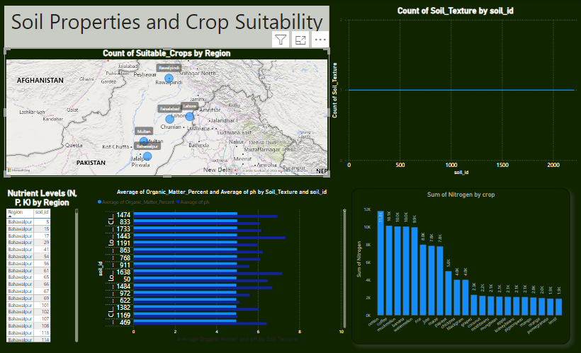

**Dashboard 2: Crop Analysis and Irrigation**

* Provides insights into irrigation sources and their influence on crop productivity.
* Visualizes the relationship between soil properties and crop suitability.

**Conclusion:** This data warehouse project, "AgroInsight: Data-Driven Agricultural Optimization," effectively integrates diverse datasets to provide actionable insights into agricultural practices. By leveraging the analysis and dashboards, stakeholders can make informed decisions to optimize resource utilization and improve crop yields.